Dear Parent / Guardian,

Thank you for your interest in EOYDC’s Summer Cultural Enrichment Program. As with every summer, this year’s Summer Program promises to be fun, educational and exciting! We have a full schedule lined up that includes art, technology, math, and literacy, field trips and more.

We are also excited to share that this summer marks the 20th anniversary of the Summer Cultural Enrichment Program! We have grown tremendously over the past two decades and are proud to have developed generations of young leaders through this program.

If you have participated in the Summer Program in the past, please make note of a couple important changes below:
- We have shifted the participant age range to serve children ages 5-12
- While the Summer Program costs approximately $1600 per child over the course of the six weeks, we work hard to provide a high quality program at a low cost to our families. In addition to the non-refundable $80 registration fee, there will be a program fee based on household income as noted below.
  - Low income (within 200% of Federal Poverty Limit) = Program fee waived
  - More than 200% above Federal Poverty Limit, but less than Alameda County median = $160
  - Above Alameda County median income = $400
- To ensure we are fulfilling our organization’s mission, 70% of spaces will be reserved for low income families. Otherwise, spaces are available on a first come, first served basis

In order to receive a reduced program fee rate, income verification must be provided. Acceptable forms of income verification include: most recent tax return, verification of unemployment benefits, verification of SSI, or public assistance verification. If you do not provide valid proof of income, then you will receive the program rate of $400 per child.

All applicants must attend a MANDATORY meeting before the start of the Summer Program. For your convenience, there are three dates. If these dates change, we will contact you using the information provided on this application. Please make arrangements to attend one of these meetings, as children who have not had a parent or guardian attend a meeting will not be accepted for enrollment.
NEW parents/guardians  June 4 10:30-Noon  June 7 5-6:30pm  June 9 5-6:30pm | RETURNING parents/guardians  June 4 12:30-1:30pm  June 7 6:30-7:30pm  June 9 6:30-7:30pm

At this meeting you will learn about how the program works, important dates, and program policies. In the meantime, please refer to the SCEP “Frequently Asked Questions” document for more information. We also encourage you to reach out to our staff with any questions or concerns you may have in advance.

Thank you for your interest and we hope to see you this summer!

Sincerely,
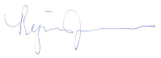

Regina Jackson
President & CEO

Summer Cultural Enrichment Program – Registration Form
June 27-August 5, 2016
*NOTE TO PREVIOUS PARTICIPANTS: Applications for previous participants are subject to review.
Acceptance into the Summer Program is based upon prior conduct and behavior.

In addition to this SCEP application, you must complete a general EOYDC participant form for your child. If you have filled out a general EOYDC participant form in the past, but have not renewed since the start of the 2015-2016 school year, you will need to fill out a new form to make sure that all information is up to date.

PLEASE PRINT CLEARLY

DATE SUBMITTED: _______________________________________

CHILD’S FULL NAME _________________________________________________________________________

ADDRESS: ____________________________________________________________________________________

CITY: _____________________________________________________ ZIP: _______________________________

HOME PHONE: ______________________________EMERGENCY PHONE: _____________________________

DATE OF BIRTH: _________________________________________ AGE: _______________________

SCHOOL DISTRICT__________________________________________________________________

SCHOOL ATTENDING_________________________________________________ CURRENT GRADE _______

MALE: ________ FEMALE: ________

RACE/ETHNICITY:

AFRICAN AMERICAN __________ LATINO/A __________ ASIAN ____________

NATIVE AMERICAN __________ WHITE __________ OTHER ________________________________

Are there any special considerations our staff should be aware of to better serve you, such as a Medical Condition? Yes _____ No _____
(If yes, please explain) ______________________________________________________________________________________________

______________________________________________________________________________________________

PARENT / GUARDIAN PRINT NAME: ______________________________________________

SIGNATURE: ___________________________________________________________________
In addition to the non-refundable $80 registration fee, program fees must be received in full prior to the start of the Summer Program. Program fees are based on household size and income. Please circle the number of people in your household along with your monthly income range on the chart below.

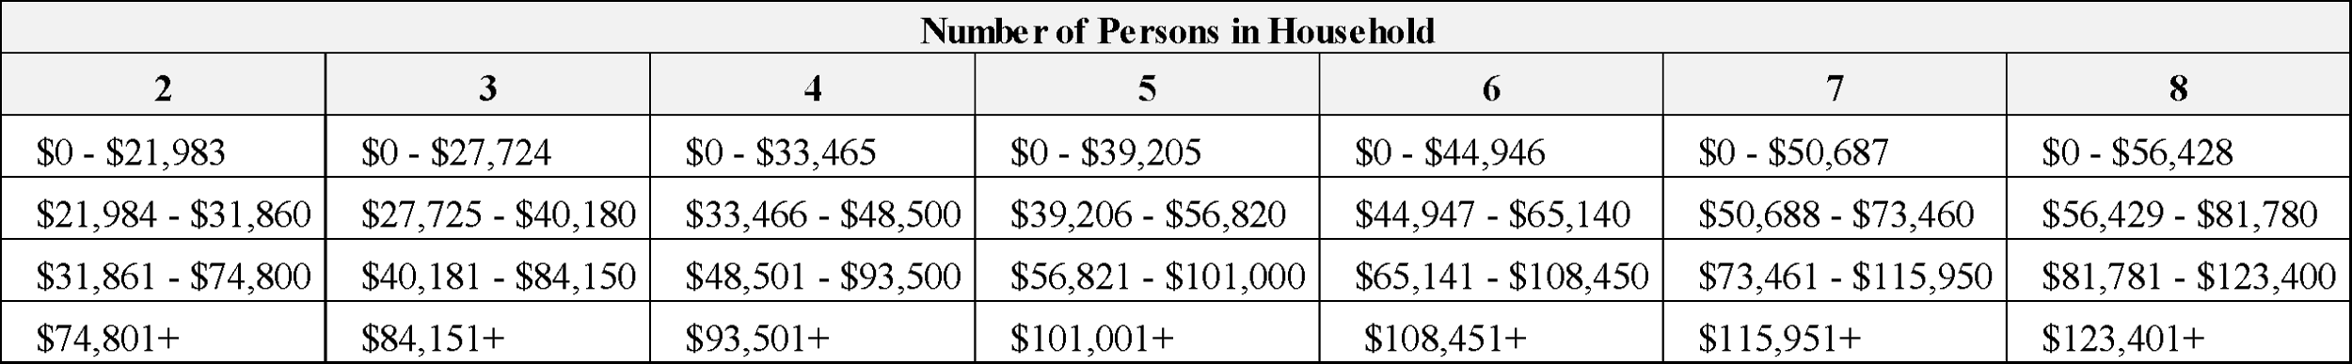

Are there any additional financial hardships that you wish to be considered?
Yes _____ No _____
(If yes, please explain) ______________________________________________________________________________________________

______________________________________________________________________________________________

PLEASE DO NOT MARK BELOW THE LINE – ADMINISTRATION ONLY

New Participant: _____ Previous Participant ______

Application Accepted? Yes ______ No ______
(If no, please explain) ______________________________________________________________________________________________

______________________________________________________________________________________________

HOUSEHOLD INCOME CATEGORY:

Within 200% FPL _____ 201% FPL - >Alameda County Median _____ +Alameda County Median _____

PAYMENT INFORMATION:

$80 Registration Fee + $________ Program Fee - $__________ hardship waiver = $___________ Total Payment
Check amount received |  | Date Received
Cash amount received |  | Date Received
On-line payment received |  | Date Received

Additional Notes:_____________________________________________________________________________________

___________________________________________________________________________________________________

Application Accepted By (Print Name):_________________________________________________Date:_____________

Signature:_____________________________________________________

